
Higher Ed Student Instructions for Ordering Tests (Self-Pay)
To register for your online assessment, please follow the directions below.
- Go to: www.languagetesting.com to purchase your test and create your account.
- On the left side of the screen, select the language to be tested, and click Schedule a Test:



On the next screen, go to the righthand column, and choose I am looking to test for teacher certification or as part of my school program.

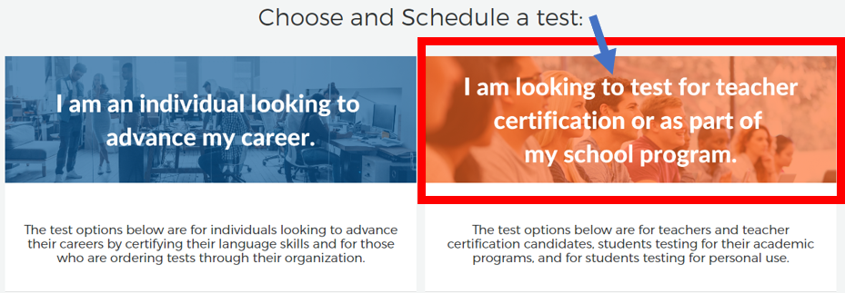

Scroll to the 2nd box down, and select I am a student or teacher and need to take an ACTFL assessment as a requirement for my academic program.

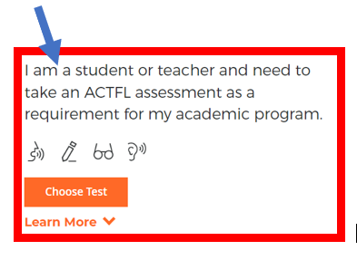

Enter your institution name in the search field for “What school or institution.” (If your institution does not appear, contact your institution’s administrator). Click Continue.

On the next page, select your test(s) – click Select Test so it turns blue; then click Continue to Schedule.

On the next page, select the proctoring option Web-Based Proctoring (or select your institution if you’ll be testing at a physical location/on campus).

Select your time zone and choose the date and time you’d like to take the test.

Select your Certificate Format and Delivery Method, if relevant. Then click Next.

If you have an existing LTI account, login. Otherwise create one and follow the payment instructions.

You can review your order or order an additional test before final checkout.

An email with test instructions will be sent to you once you have finalized your payment.

Good luck on your test!
For Customer Support: 800-486-8444 (or +1 914.963.7110), Option 1
Or email support@languagetesting.com
Monday-Friday, 8am - 7pm Eastern time

